COMMUNITY OUTREACH VOLUNTEERISM BY STUDENTS– 2020- 2021

Mr. Jayarama and Ms. Latha of 1st semester from the Department have participated as the Volunteers in Covid 19 Vaccination drive on 22nd April 2021 at Mayabazar, Bangalore organised by Mamata Health Institute
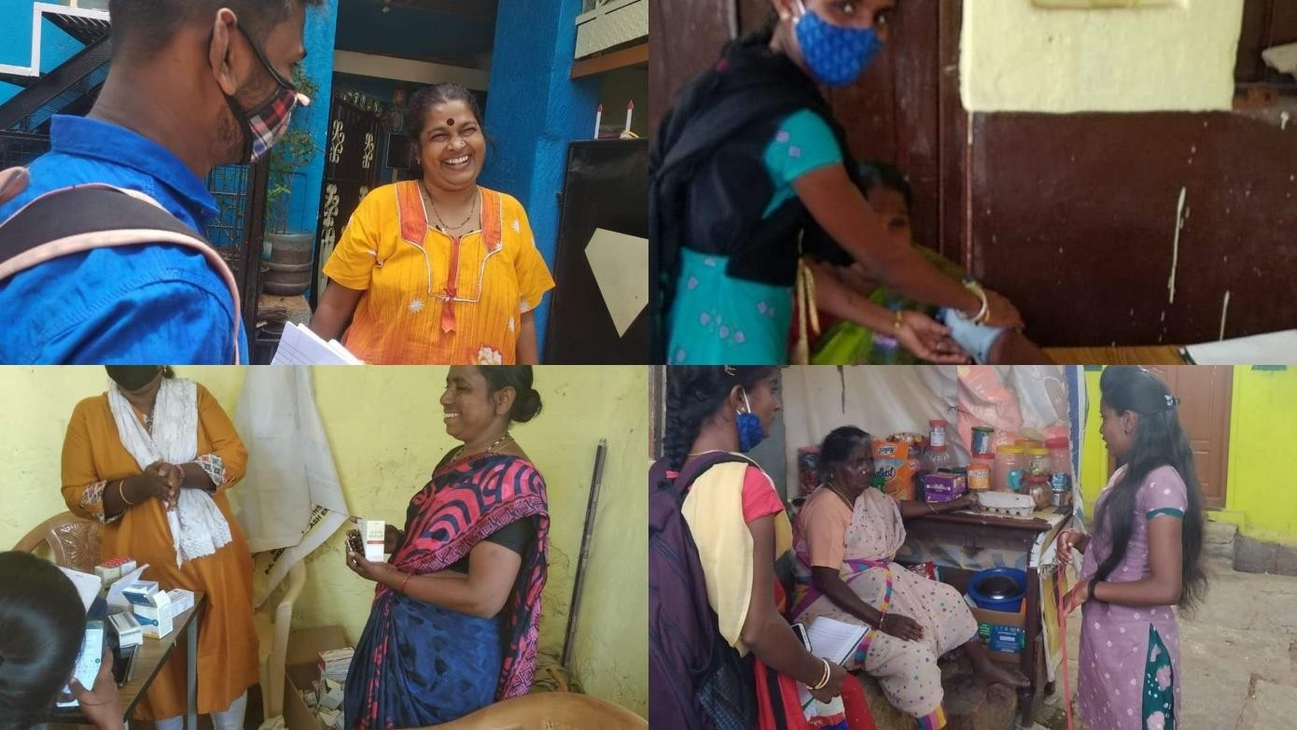

Mr. Jayarama and Ms. Latha of 1st semester from the Department have participated as the Volunteers in the Medical Camp on 26th March 2021 conducted by Mamata Health Institute for Women and Child at Vannarpet.
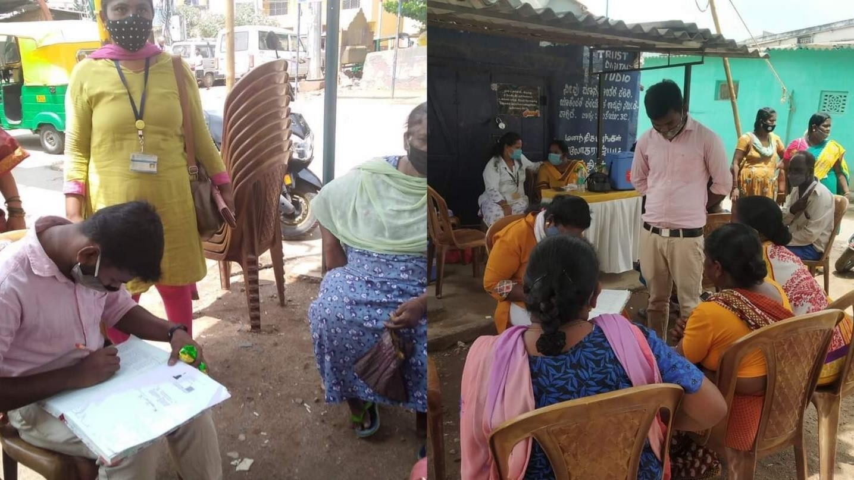

Mr Jayaram and Ms Latha, The Social Work Trainees of the department of Social Work volunteered in the awareness programme on Nutrition and Health for Adolescents of the Mayabazar on International Youth Day Celebration organised by Mamta Health Institute at Mayabazar Community on 12th August 2021.
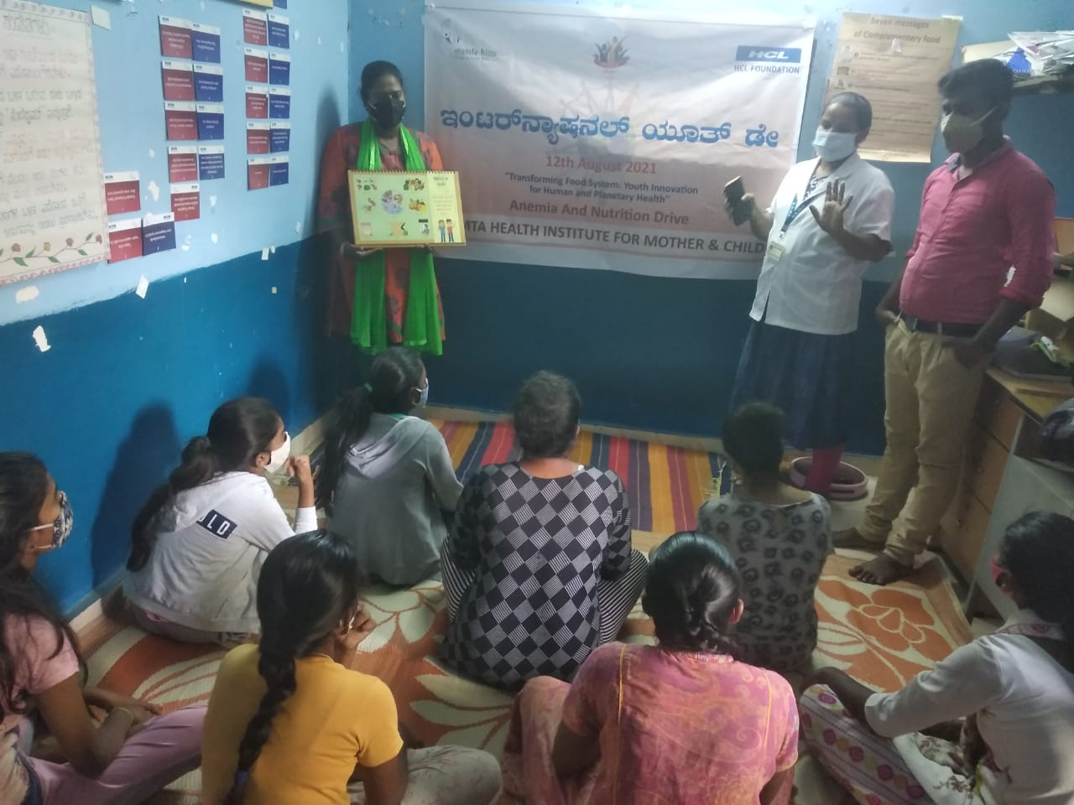

Ms Asha, The Social Work Trainee of the department of Social Work volunteered in Awareness Programme under the Pradhan Mantri Poshan Abhiyan, and Matru Vandana Yojana organised by CDPO office Anekal for the employees of Aditya Birla Fashion and Retail Ltd. Marsur Gate on 16th September 2021.
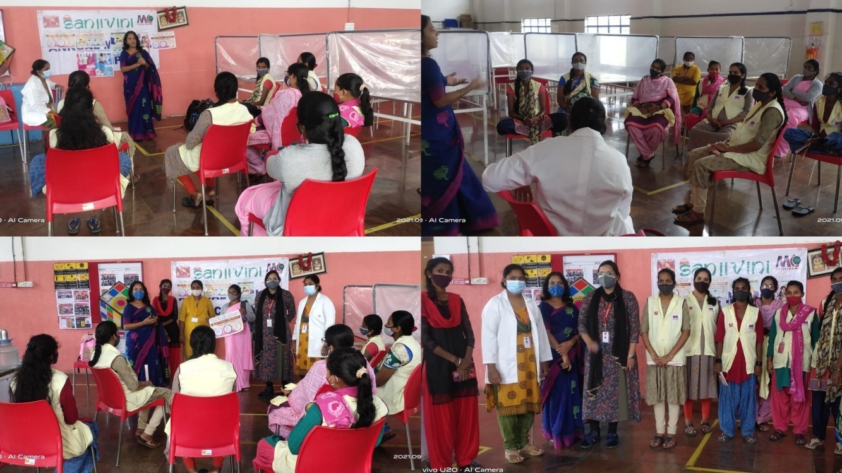
Mr.Vinod Kumar GN and Mr. Srinath T, the Social Work Trainees of 2nd Semester, Department of Social Work, The Oxford College of Arts have volunteered in Covid Raksha Kit Distribution and Covid Awareness Drive held by Head Held High Foundation and supported by Japan Amway from 21st to 25th of September 2021.
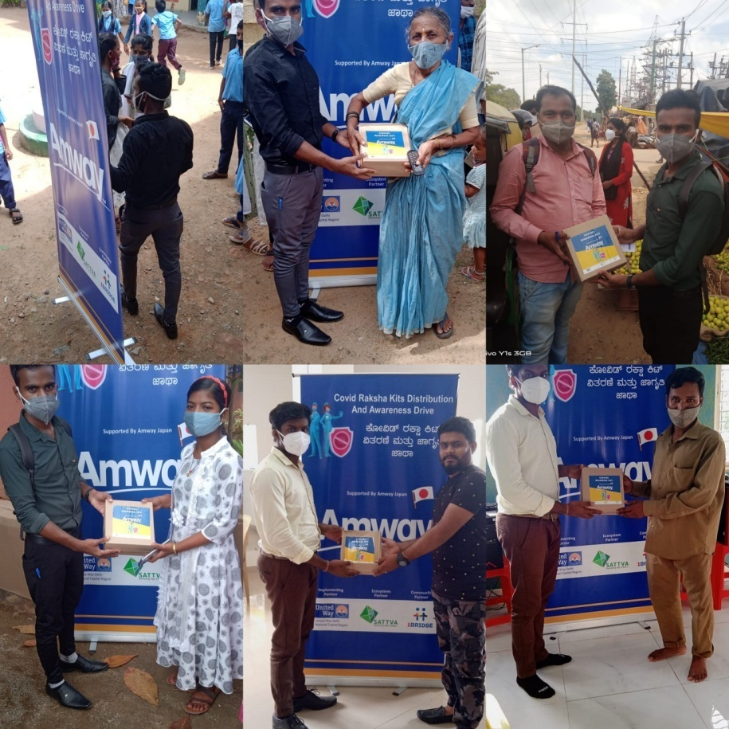
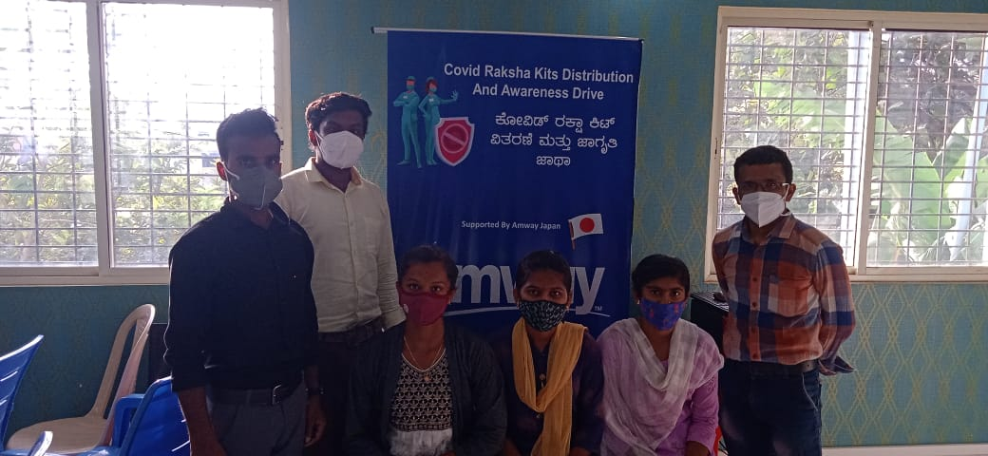

Ms. Christina Anna John, Mr. Aswin Rajagopalan Nair, Mr. Jayarama the Social Work Trainees of 2nd Semester, the Department of Social Work, The Oxford College of Arts have volunteered in mobilising the people for General Health Camp and Organisation of Camp held at Flower Garden by ACTIONAID on 30th September, 2021.
